Notes for Lectorial on Structuring Space

**Slide 4**

If we direct an imaginary ray away from the pupil of one of our eyes into the world, it will eventually encounter a point on the surface of an object; except for those cases when the ray reaches the empty sky. That surface point has a colour and a distance from the eye. Of course, in the real world, light travels in the reverse direction and information about the surface colour is recorded by cone receptors at the back of the eye, but the point is that there is only one colour in the away direction corresponding to each retina location.

**Slide 7**

Edge detection in noise (distracting short unaligned edges)

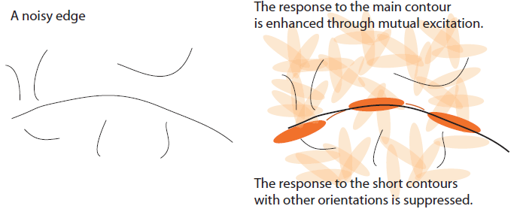

**Slide 13**

IT cortex is the inferotemporal cortex is the last stage in the visual system and it focuses on object recognition.

**Slide 17**

1. Queries, find the highest point; find the lowest point; find whether the line slopes up or down overall.
2. Queries, find the highest point; find the lowest point; find whether the line slopes up or down overall.
3. Query: determine the vertical extent of the grey band at a particular point on the black line.

**Slide 18**

For the most part, when we see patterns in graphic designs, we are relying on the same neural machinery that is used to interpret the everyday environment. There is, however, a layer of meaning—a kind of natural semantics—that is built on top of this. For example, we use a *big* graphical shape to represent a *large* quantity in a bar chart. We use something graphically attached to another object to show that it is *part of* it.